Hexagram | Energies |  |  | Name |  | Meaning |  |  |  | Hexagram |  | Energies |  | Name |  |  | Meaning
☰  ☰ 1 | 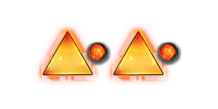 |  |  | Heaven |  | Possessing creative power and skill. |  |  |  | ☶  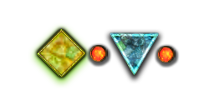  ☲ 22 |  |  |  | Adornment |  |  | Embellishing.
☷  ☷ 2 | 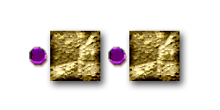 |  |  | Earth |  | Needing knowledge and skill. Do not force matters and go with the flow. |  |  |  | ☶  ☷ 23 |  | 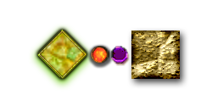 |  | Stripping Away |  |  | Stripping, Flaying.
☵  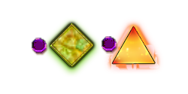  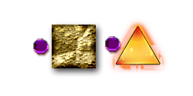  ☳ 3 |  |  |  | Difficulty |  | Sprouting. |  |  |  | ☷  ☳ 24 |  |  |  | Return |  |  | Returning.
☶  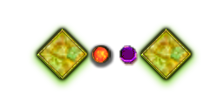  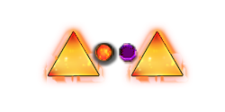  ☵ 4 |  |  |  | Darkness |  | Detained, enveloped and inexperienced. |  |  |  | ☰  ☳ 25 |  |  |  | No Error |  |  | Without Rashness.
☵  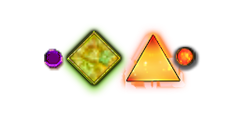  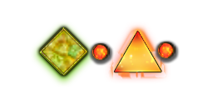  ☰ 5 |  |  |  | Waiting |  | Uninvolved (Wait for now), Nourishment. |  |  |  | ☶  ☰ 26 |  |  |  | Great Buildup |  |  | Accumulating Wisdom.
☰  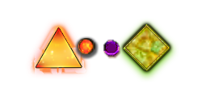  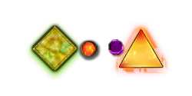  ☵ 6 |  |  |  | Contention |  | Engagement in Conflict. |  |  |  | ☶  ☳ 27 |  |  |  | Nourishment |  |  | Seeking Nourishment.
☷  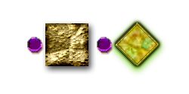  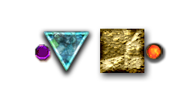  ☵ 7 |  |  |  | The Army |  | Bringing Together, Teamwork. |  |  |  | ☱  ☴ 28 |  |  |  | The Passing Of Greatness |  |  | Great Surpassing.
☵  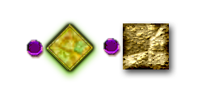  ☷ 8 |  |  |  | Accord |  | Union. |  |  |  | ☵  ☵ 29 |  | 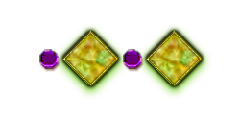 |  | Multiple Danger |  |  | Darkness, Gorge.
☴  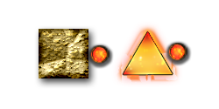  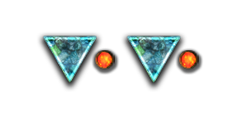  ☰ 9 |  |  |  | Small Obstruction |  | Accumulating Resources. |  |  |  | ☲  ☲ 30 |  |  |  | Fire |  |  | Clinging, Attachment.
☰  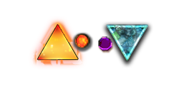  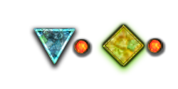  ☱ 10 |  |  |  | Treading |  | Continuing with Alertness. |  |  |  | ☲  ☶ 31 |  |  |  | Sensing |  |  | Attraction.
☷  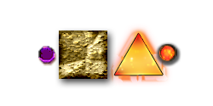  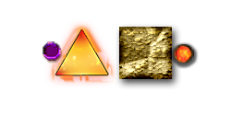  ☰ 11 |  |  |  | Tranquility |  | Pervading. |  |  |  | ☳  ☴ 32 |  |  |  | Constancy |  |  | Perseverance.
☰  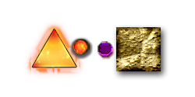  ☷ 12 |  |  |  | Obstruction |  | Stagnation. |  |  |  | ☰  ☶ 33 |  | 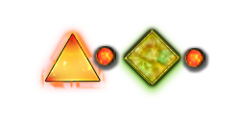 |  | Withdrawal |  |  | Withdrawing.
☰  ☲ 13 | 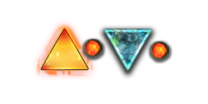 |  |  | Sameness With People |  | Fellowship, Partnership. |  |  |  | ☳  ☰ 34 |  | 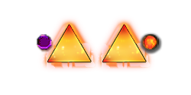 |  | The Power Of The Great Advance |  |  | Great Boldness.
☲  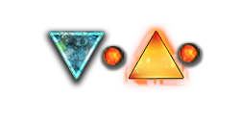  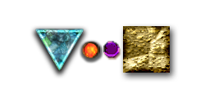  ☰ 14 |  |  |  | Great Possession |  | Independence, Freedom. |  |  |  | ☲  ☷ 35 |  |  |  | Advance |  |  | Expansion, Promotion.
☷  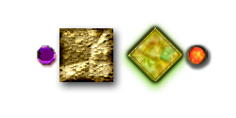  ☶ 15 |  |  |  | Humility |  | Being Reserved, Refraining. |  |  |  | ☷  ☲ 36 |  | 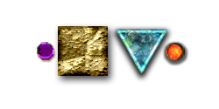 |  | Damage Of Illumination |  |  | Brilliance Injured.
☳  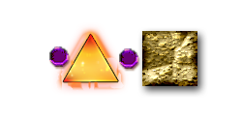  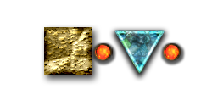  ☷16 |  |  |  | Joy |  | Inducement, New Stimulus. |  |  |  | ☴  ☲ 37 |  |  |  | People In The Home |  |  | Family.
☱  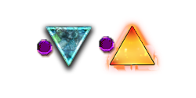  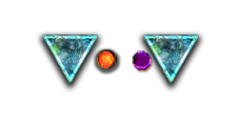  ☳ 17 |  |  |  | Following |  | Following. |  |  |  | ☲  ☱ 38 |  |  |  | Opposition |  |  | Division, Divergence.
☶  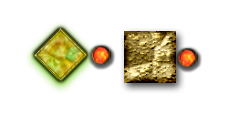  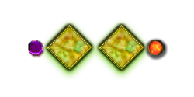  ☴ 18 |  |  |  | Degeneration |  | Repairing. |  |  |  | ☵  ☶ 39 |  |  |  | Trouble |  |  | Halting, Hardship.
☷  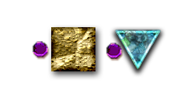  ☱ 19 |  |  |  | Overseeing |  | Approaching Goal, Arriving. |  |  |  | ☳  ☵ 40 |  | 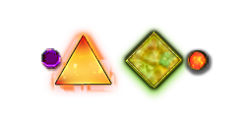 |  | Solution |  |  | Liberation, Solution.
☴  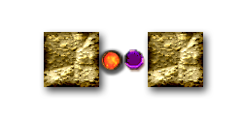  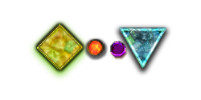  ☷ 20 |  |  |  | Observing |  | The Withholding. |  |  |  | ☶  ☱ 41 |  |  |  | Reduction |  |  | Decrease.
☲  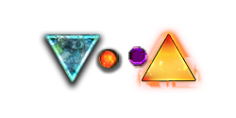  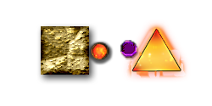  ☳ 21 |  |  |  | Biting Through |  | Deciding. |  |  |  | ☴  ☳ 42 |  |  |  | Increase |  |  | Increase.
☱  ☰ 43 | 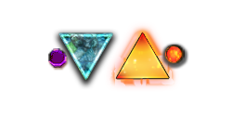 |  |  | Decision |  | Separation. |  |  |  | 65
☰  ☴ 44 | 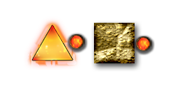 |  |  | Meeting |  | Encountering. |  |  |  | 66
☱  ☷ 45 | 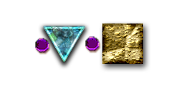 |  |  | Gathering |  | Association, Companionship. |  |  |  | 67
☷  ☴ 46 | 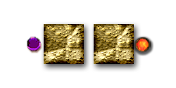 |  |  | Rising |  | Growing Upward. |  |  |  | 68
☱  ☵ 47 | 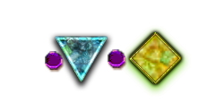 |  |  | Exhaustion |  | Exhaustion. |  |  |  | 69
☵  ☴ 48 | 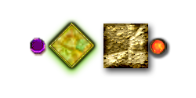 |  |  | The Well |  | Replenishing, Renewal. |  |  |  | 70
☱  ☲ 49 | 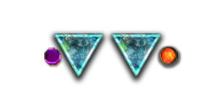 |  |  | Change |  | Abolishing the Old. |  |  |  | 71
☲  ☴ 50 | 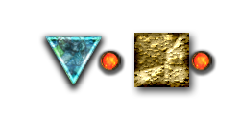 |  |  | The Cauldron |  | Establishing the New. |  |  |  | 72
☳  ☳ 51 | 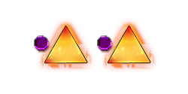 |  |  | Thunder |  | Mobilizing. |  |  |  | 73
☶  ☶ 52 | 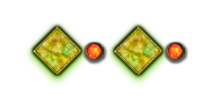 |  |  | Mountain |  | Immobility. |  |  |  | 74
☴  ☶ 53 | 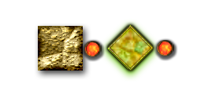 |  |  | Gradual Progress |  | Auspicious Outlook, Infiltration. |  |  |  | 75
☳  ☱ 54 | 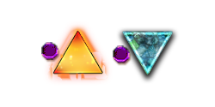 |  |  | Marrying A Young Girl |  | Marrying. |  |  |  | 76
☳  ☲ 55 | 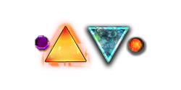 |  |  | Richness |  | Goal Reached, Ambition Achieved. |  |  |  | 77
☲  ☶ 56 | 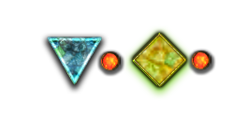 |  |  | Travel |  | Travel. |  |  |  | 78
☴  ☴ 57 | 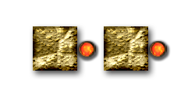 |  |  | Wind |  | Subtle Influence. |  |  |  | 79
☱  ☱ 58 | 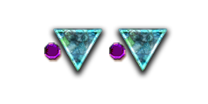 |  |  | Delight |  | Overt Influence. |  |  |  | 80
☴  ☵ 59 | 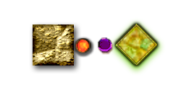 |  |  | Dispersal |  | Dispersal. |  |  |  | 81
☵  ☱ 60 | 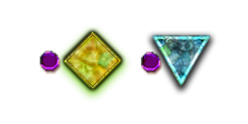 |  |  | Regulation |  | Discipline. |  |  |  | 82
☴  ☱ 61 | 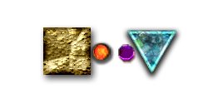 |  |  | Sincerity In The Center |  | Staying Focused, Avoid Misrepresentation. |  |  |  | 83
☳  ☶ 62 | 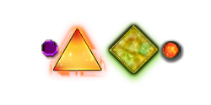 |  |  | Small Excess |  | Small Surpassing. |  |  |  | 84
☵  ☲ 63 | 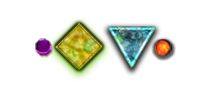 |  |  | Settled |  | Completion. |  |  |  | 85
☲  ☵ 64 | 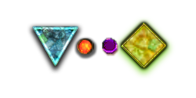 |  |  | Unsettled |  | Incomplete. |  |  |  | 86
 |  | 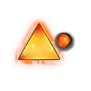  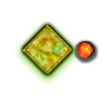 | 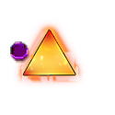 |  | 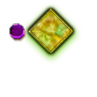 |  |  | 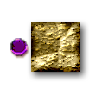 | 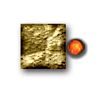 |  | 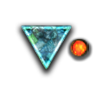 |  | 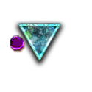 |  | 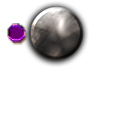 | 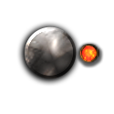 |  |  | 
 |  | 1 | 34 |  | 5 |  | 26 | 11 | 9 |  | 14 |  | 43
 |  | 25 | 31 |  | 3 |  | 27 | 24 | 42 |  | 21 |  | 17
 |  | 6 | 40 |  | 29 |  | 4 | 7 | 59 |  | 64 |  | 47
 |  | 33 | 62 |  | 39 |  | 52 | 15 | 53 |  | 56 |  | 31
 |  | 12 | 16 |  | 8 |  | 23 | 2 | 20 |  | 35 |  | 45
 |  | 44 | 32 |  | 48 |  | 18 | 46 | 57 |  | 50 |  | 28
 |  | 13 | 55 |  | 63 |  | 22 | 36 | 37 |  | 30 |  | 49
 |  | 10 | 54 |  | 60 |  | 41 | 19 | 61 |  | 38 |  | 58

